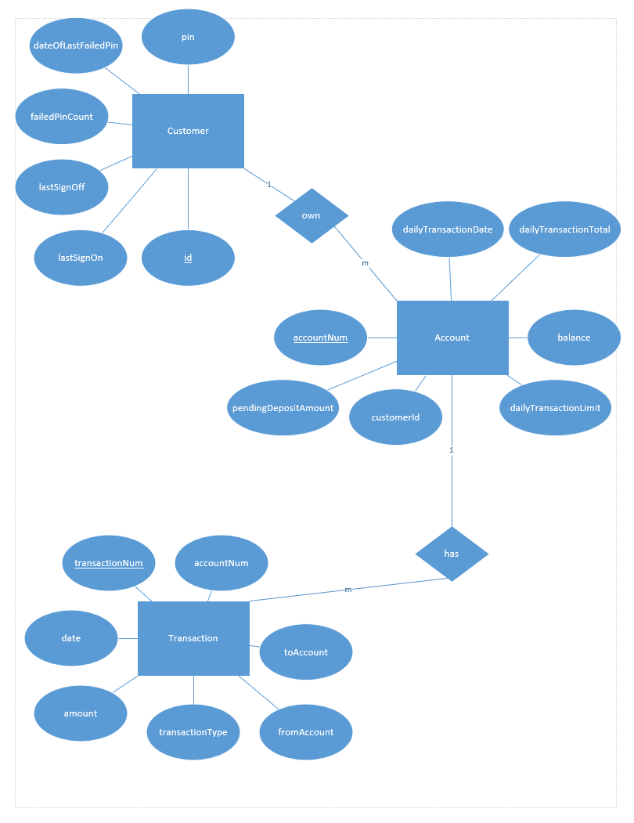

Figure ER Diagram

Customer:

|  |  |  |  |  |  |
| --- | --- | --- | --- | --- | --- |
| id | pin | lastSignOn | lastSignOff | failedPinCount | dateOfLastFailedPin |

Account:

|  |  |  |  |  |  |  |
| --- | --- | --- | --- | --- | --- | --- |
| accountNum | dailyTransactionDate | dailyTransactionTotal | balance | dailyTransactionLimit | customerId | pendingDepositAmount |

Transaction:

|  |  |  |  |  |  |  |
| --- | --- | --- | --- | --- | --- | --- |
| transactionNum | Date | Amount | accountNum | transactionType | fromAccount | toAccount |